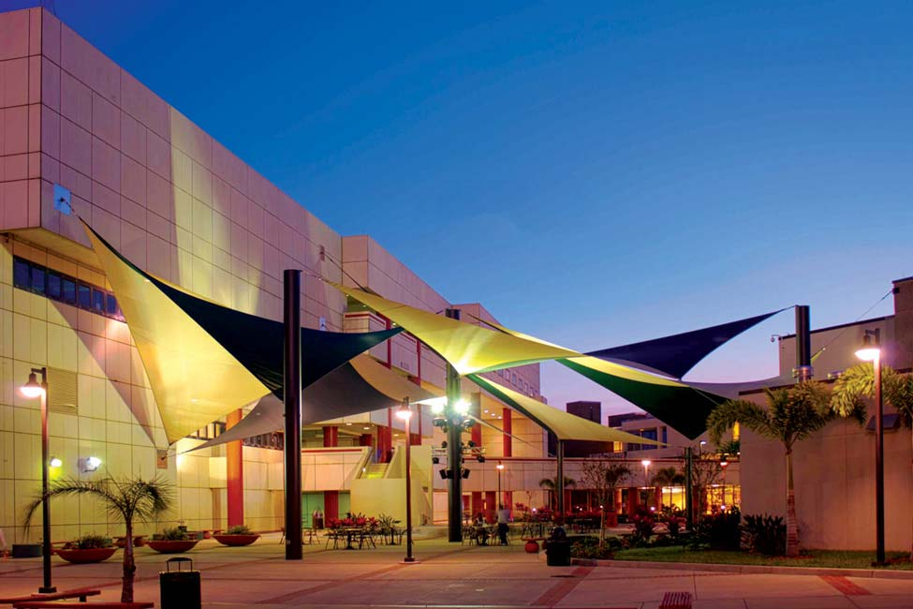

HILLSBOROUGH COLLEGE

Annual Security and Fire Safety Report
Issued for 2024 – 2025 Academic Year

2025

A Message from the Director of Public Safety and Emergency Management

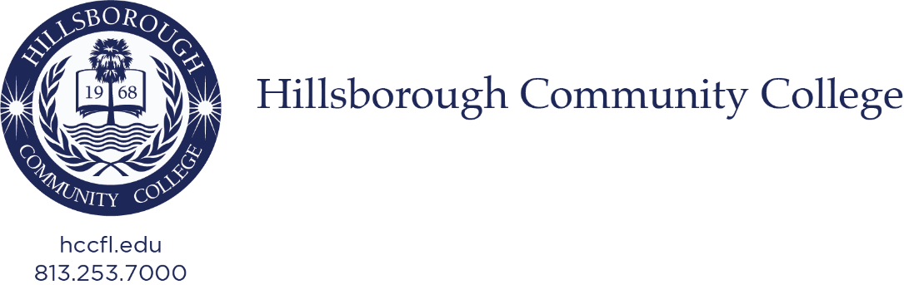

Dear Hillsborough College Community,

On behalf of the Department of Public Safety and Emergency Management, I extend a warm welcome to all students, faculty, staff, and visitors as we share the 2025 Annual Security and Fire Report. At Hillsborough College, your safety and well-being are our top priorities, and this report reflects our unwavering commitment to fostering a secure and supportive campus environment. As you read this report, you’ll notice the transition from Hillsborough Community College to Hillsborough College. This is a significant milestone in providing additional educational opportunities for students and the community. For more information about the rebranding, please see the Hillsborough College press release: Hillsborough Community College Becoming Hillsborough College | Hillsborough Community College.

This comprehensive report provides valuable information about the resources available to you, including important safety policies, procedures, and crime prevention programs. It also contains crime statistics for the previous three years, in compliance with the Clery Act. This transparency is designed to keep you informed and empowered to contribute to our shared goal of a safe campus. We encourage you to review the report, familiarize yourself with our safety programs, and reach out to our team with any questions or concerns.

Our dedicated Department Public Safety team works tirelessly to ensure preparedness, promote awareness, and respond effectively to any situation. Together, we can maintain a campus where everyone feels safe to learn, work, and thrive.

Thank you for being an active partner in keeping Hillsborough College a secure and welcoming community.

Sincerely,

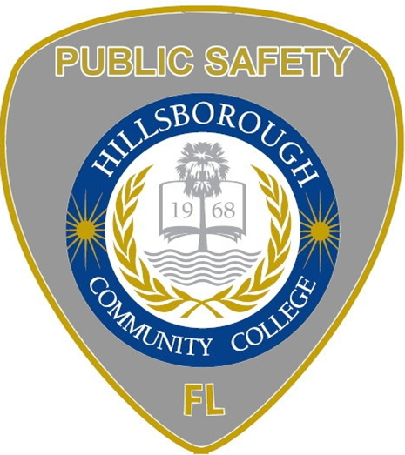

Michael Hutner
Director of Public Safety and Emergency Management

Hillsborough College Building Locations











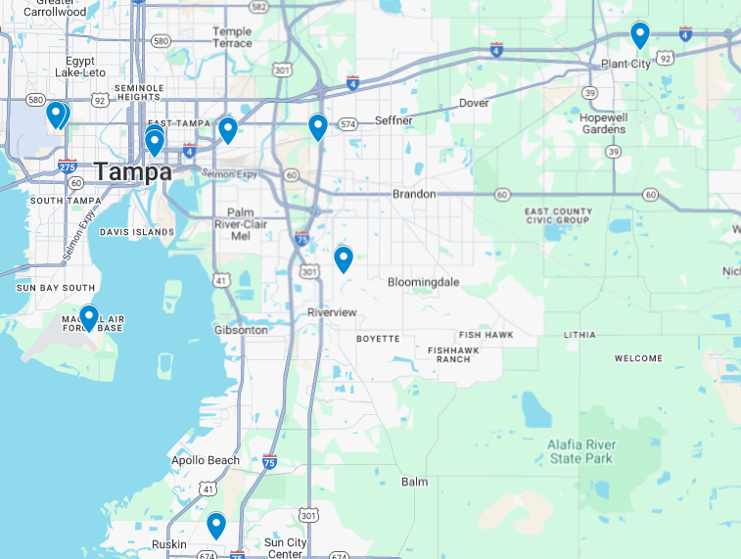
Dale Mabry Campus
4001 W Tampa Bay Blvd, Tampa, FL 33614

Brandon Campus
10451 Nancy Watkins Dr., Tampa, FL 33619

Ybor Campus
2112 N. 15th St., Tampa, FL 33605

Collaboration Studio
1602 N. 15th St., Tampa, FL 33605

SouthShore Campus
551 24th St. NE., Ruskin, FL 33570

The Regent
6437 Watson Rd., Riverview, FL 33578

Plant City Campus
1206 N. Park Rd., Plant City, FL 33563

MacDill Center
8102 Condor St., MacDill Air Force Base, FL 33621

Ybor City Campus Training Center
5610 E. Columbus Dr., Tampa, FL 33619

Dr. Gwendolyn W. Stephenson District Administration Center
4115 N. Lois Ave., Tampa, FL 33614

HILLSBOROUGH COLLEGE LOCATIONS

Hillsborough College Online
Home | Hillsborough Community College

INTRODUCTION

The Clery Act, enacted in 1990 as the Jeanne Clery Disclosure of Campus Security Policy and Campus Crime Statistics Act, is a U.S. federal law requiring colleges and universities that receive federal funding to promote campus safety through transparency. Named after Jeanne Clery, a student murdered at Lehigh University in 1986, the Act mandates institutions to annually report crime statistics for incidents on or near campus, maintain a public crime log, issue timely warnings about ongoing safety threats, and publish an Annual Security Report detailing safety policies and prevention programs. Additionally, it requires specific procedures for handling sexual assault and missing student cases. The law aims to enhance campus safety and accountability.

Hillsborough College (HC), Tampa, Florida, prepares this report in compliance with the Clery Act. Campus crime, arrests, and referral statistics contained within this report include those reported to the Hillsborough College Department of Public Safety (DPS), law enforcement agencies that have jurisdiction over Hillsborough College-owned and/or controlled properites, and other designated “campus security authorities” as defined under the Clery Act.

As required by federal law, Hillsborough College publishes this report by October 1st of each year and provides crime statistics for the previous three (3) calendar years. Hard copies may be obtained at the Hillsborough College Collaboration Studio, 1602 N. 15th St., Tampa, FL, Room 331, by contacting the DPS at 813-253-7911 or by visiting: Jeanne Clery Act | Hillsborough Community College (hccfl.edu)

Need Additional Information?
https://www.clerycenter.org/


©2020 Clery Center for Security on Campus. All rights reserved. The Clery Center and the
NCSAM logos are registered trademarks of Clery Center for Security on Campus.

Table of Contents
A Message from the Director of Public Safety and Emergency Management 2
Hillsborough College Building Locations 3
INTRODUCTION 4
Department of Public Safety 7
Mission Statement 7
About us 7
Relationship with Local, State, and Federal Law Enforcement Agencies 8
Preparing The Annual Security Report 9
Reporting Crimes and Other Emergencies 9
Reporting to Hillsborough College’s Department of Public Safety 9
Tips For Reporting Crimes or Emergencies 10
Voluntary and Confidential Reporting 10
Guardian Mobile App 10
Reporting to Other Campus Security Authorities 11
Pastoral and Professional Counselors 12
Timely Warning Reports – Crime Alerts 12
Emergency Response and Evacuation Procedures 13
Emergency Management at Hillsborough College 13
Drills, Exercises, and Training 13
Emergency Notification 13
Security of and Access to College Facilities 14
Special Considerations for Hawks Landing Housing Access 14
Sexual Misconduct and Title IX 14
Sexual Misconduct Prevention and Response 15
Introduction 15
Reporting an Incident 15
State of Florida Crime Definitions 16
On & Off-Campus Resources 17
Accommodations 17
Victim Confidentiality 18
Bystander Intervention and Risk Reduction 19
Education & Awareness Programs 19
Conduct Proceedings 20
Personal Safety 22
Rape and Sexual Assault Victim Information 23
Guidance For Victims of Sexual Assault 23
Our Commitment to Addressing Sexual Assault/Rape 24
College Procedures for Responding to Reports of Sexual Assault 24
College Disciplinary Procedures in Sexual Assault Incidents 25
Sex Offender Registration – Campus Sex Crimes Prevention Act 25
Hillsborough College Security Policies, Crime Prevention & Safety Awareness Programs 25
Hillsborough College Threat Assessment Team 25
Missing Student Notification Policy 26
Daily Crime and Fire Log 26
Crime Prevention and Safety Awareness Programs 26
Hillsborough College Policies Governing Alcohol and Other Drugs 27
Hillsborough College Alcohol and Drug Policy 27
Policies Specific to Students 27
Policies Specific to Faculty and Staff 27
Florida’s Alcohol Laws 28
Annual Disclosure of Crime Statistics 28
Clery Act Reporting 28
Criminal Offenses 28
Hate Crimes 29
Violence Against Women Act (VAWA) Offenses 30
Arrests and Disciplinary Actions 31
Stop Campus Hazing Act Offense 31
Crime Locations (“Clery Geography”) 32
Unfounded 32
Crime Statistics 33
Brandon Campus 34
Collaboration Studio 35
Dale Mabry Campus 36
District Administration Center Building 37
Hawks Landing 38
MacDill Center 39
Plant City Campus 40
SouthShore Campus 41
The Regent 42
Ybor Campus 43
Ybor City Campus Training Center 44
Annual Fire Safety Report 45
Fire Safety Definitions 45
Hawks Landing Residence Fire Drills 45
Fire Safety 46
Description of On-Campus Student Housing Fire Safety Systems – Hawks Landing 46
Fire Safety Education and Training Programs for Students, Faculty, and Staff 46
Fire Incident Reporting 47
Plans for Future Improvements in Fire Safety 47

Campus Safety and Security

Department of Public Safety


Mission Statement
The mission of the Department of Public Safety and Emergency Management is to develop a safe and secure environment in support of the educational mission of the College. Within our community, the Department of Public Safety and Emergency Management is committed to its leadership role in developing programs, methods, and approaches to assist the College toward achieving a safe and secure environment.

About us
Hillsborough College Department of Public Safety (DPS) does not have a sworn campus police force but employs non-sworn, unarmed Public Safety Officers who do not possess powers of arrest. All Hillsborough College Public Safety Officers have Class D security licenses issued by the State of Florida and/or an active law enforcement certification. The DPS strives to provide exceptional security, safety, crime prevention, and emergency medical and fire response services for the college. The DPS is responsible for providing security and safety for the entire college community on five primary campuses, three satellite sites, District Administration Center, Collaboration Studio, Tennis Center, Trinkle Center, and Hawks Landing Residence Complex, located in the City of Tampa, the City of Plant City, and throughout Hillsborough County. The DPS Public Safety Officers provide service 24 hours a day, 7 days a week, 365 days a year, consisting of vehicle patrols, bike patrols, foot patrols, and monitoring by a new state-of-the-art video surveillance camera network. The DPS created focused patrol Districts on each campus for improved visibility, deterrence of crime and misconduct, response times to incidents, responsibility ownership and accountability, and improved tracking of operational data. The DPS designed a modern style of patrol uniform for improved identification and authority. The DPS is a member of the International Association of Campus Law Enforcement Administrators (IACLEA) for professional development with advanced and specialized training. The DPS has deployed modern enhanced equipment, including utility campus patrol vehicles with essential medical and safety equipment onboard, lights for darkness illumination, warning lights for incident scenes, reflective traffic cones, and law enforcement-grade flashlights.

The DPS also staffs a 24/7/365 Central Dispatch Center with video surveillance and alarm monitoring in a centralized state-of-the-art communications center. DPS communicates on a multi-channel interoperability radio system that is maintained by the Hillsborough County Sheriff’s Office (HCSO), which allows DPS to communicate with all our mutual aid partners throughout the County, the City of Tampa, and the City of Plant City. The DPS is currently enhancing its radio dispatch system.

The DPS is staffed by a Director of Public Safety, a Manager of Public Safety, Administration and Operation Lieutenants, Campus Sergeants, Proprietary Public Safety Officers, Dispatchers, a Staff Assistant, and a Parking Services Specialist. Each of the five primary campuses has a DPS Sergeant and several Officers. The Campus Sergeant is also the liaison to the Campus President and Administration. Each campus office maintains its own found property storage.

A former combined staffing model of proprietary patrol officers and contracted patrol officers has been replaced with all proprietary patrol officers on all five campuses. Contracted patrol officers remain at the satellite locations. Hillsborough College also contracts with the City of Tampa Police Department, Hillsborough County Sheriff’s Office, and the Plant City Police Department to provide all law enforcement functions for special needs.

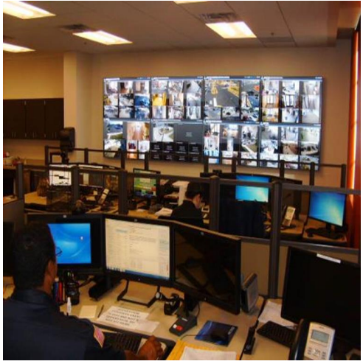
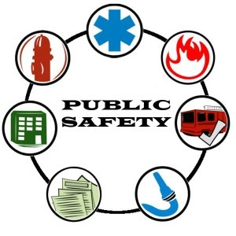

Relationship with Local, State, and Federal Law Enforcement Agencies
At Hillsborough College, public safety officers are proactive in ensuring safety. While public safety officers do not have arrest authority beyond that of an ordinary citizen, they are quick to refer all criminal incidents to local law enforcement having jurisdictional authority. The DPS maintains a highly professional and cooperative working relationship with local law enforcement and fire rescue personnel. The City of Tampa Police Department and Tampa Fire Rescue provide services within the City of Tampa. The Hillsborough County Sheriff’s Office and Hillsborough County Fire Rescue provide services in the unincorporated areas of Hillsborough County. The Plant City Police Department and Plant City Fire Rescue provide services within the City of Plant City. These agencies will promptly respond to campus emergencies, conduct criminal investigations, and complete reports. All crime victims and witnesses are strongly encouraged to report crimes to the DPS and the appropriate law enforcement agency.

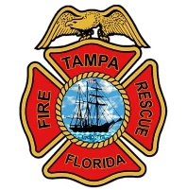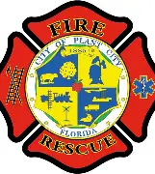

Annual Security Report

Preparing The Annual Security Report
To meet requirements of the Clery Act, this annual security report is compiled and prepared by Hillsborough College Department of Public Safety and Emergency Management in cooperation with several College entities, including Student Affairs, Residence Life, Title IX and Civil Rights Compliance, and others designated as Campus Security Authorities (CSAs).

Crime and disciplinary referral statistics are collected from the above groups, while statistical information for activity that occurs on and off campus is retrieved from the local law enforcement authorities that have jurisdiction.

This report provides statistics for the previous calendar year (2024) concerning reported crimes that occurred on campus, in certain off-campus buildings, or property owned, leased, or controlled by Hillsborough College. This report also includes institutional policies concerning campus security and policies regarding sexual assault, alcohol, and other drugs.

The Hillsborough College community is encouraged to use this report as a guide for safe practices on and off campus. Hillsborough College distributes a notice of the availability of this Annual Security and Fire Safety Report by October 1st of each calendar year. Anyone, including prospective students and employees, may obtain a paper copy of this report at the Hillsborough College Collaboration Studio, 1602 N. 15th St., Tampa, FL, Room 331, by contacting the DPS at 813-253-7911 or by visiting: Jeanne Clery Act | Hillsborough Community College (hccfl.edu)

Reporting Crimes and Other Emergencies
Hillsborough College has several ways for campus community members and visitors to report crimes, serious incidents, and other emergencies to appropriate College officials. Regardless of how and where you decide to report these incidents, it is critical for the safety of the entire Hillsborough College community that you immediately report all incidents to Hillsborough College DPS at 813-253-7911 to ensure a thorough investigation and appropriate follow-up actions, including issuing a timely warning or emergency notifications.



Reporting to Hillsborough College’s Department of Public Safety
We encourage all members of the Hillsborough College community to report all crimes and other emergencies in a prompt and accurate manner. In the event of an emergency or commission of a crime on or near college property, students, faculty, and staff are directed to contact the appropriate law enforcement agency via 911 and then contact Hillsborough College DPS at 813-253-7911. Criminal incidents requiring attention beyond the authority of HC DPS will be referred to the local law enforcement agency having jurisdiction over that location. Prompt reporting to HC DPS will ensure that timely warnings or emergency notifications are issued to the Hillsborough College community when necessary, and the proper disclosure of crime statistics is provided.

Tips For Reporting Crimes or Emergencies
Be prepared to give the location.
- Take time to learn the campuses, centers, and especially frequently visited areas. Take note of building numbers, names, and landmarks, which will help DPS and law enforcement respond.

Give as much detail as possible.
- When giving descriptions of individuals, include race, approximate height and weight, physical features, clothing, accessories, and anything else that would help responders recognize the individual.

- When describing a vehicle, include make, model, color, license plate, unique features, visible damage, and a description of the driver and passengers, if any.

*Remember - Do not approach or attempt to apprehend people suspected of being involved in a crime or incident.

Voluntary and Confidential Reporting
If crimes are never reported, little can be done to help other members of the community from also being victims. We encourage Hillsborough College community members to report crimes promptly and to participate in and support crime prevention efforts. The Hillsborough College community will be much safer when all community members participate in safety and security initiatives.

If you are the victim of a crime or want to report a crime, but do not want to pursue action within Hillsborough College or the criminal justice system, we ask that you consider filing a voluntary, confidential report with Hillsborough College DPS. Depending upon the circumstances of the crime you are reporting, you may be able to file a report while maintaining your confidentiality. The purpose of a confidential report is to comply with your wish to keep your Personally Identifiable Information (PII) confidential, while taking steps to ensure your safety and the safety of others. The confidential report allows the College to compile accurate records on the number of types of incidents occurring on campus. Reports filed in this manner are counted and disclosed in the Annual Security and Fire Safety Report.

Online confidential reporting for Sexual Assault, Sexual Harassment, Stalking, Dating Violence, and Domestic Violence can be made at: Title IX and Civil Rights Intake Form

Additional information concerning Title IX can be found at: Title IX and Civil Rights Compliance | Hillsborough Community College (hccfl.edu)

In limited circumstances, Hillsborough College DPS and/or the Title IX and Civil Rights Office may not be able to ensure confidentiality and will inform you in those specific cases.

Anyone may call local law enforcement via 911 and/or call Hillsborough College DPS at 813-253-7911 to report crimes, suspicious behavior, or emergencies. Callers may remain anonymous.

Guardian Mobile App
Hillsborough College provides all currently registered students, faculty, and staff, the ability to download a mobile App. The Hawk Guardian App provides the user with several features. It allows users the ability to place emergency calls directly to 911 or directly to HC DPS and the ability to send “Text Tips” directly to HC DPS via text message.

The App also provides the user with a “Safety Timer,” which allows them the ability to have a virtual escort. The virtual escort is conducted by “Guardians,” which the user identifies via the App. This App can be downloaded from the Apple App Store or the Google Play Store under “Rave Guardian.” Only current registered students or employed faculty and/or staff can provide tips or contact HC DPS directly through the App.

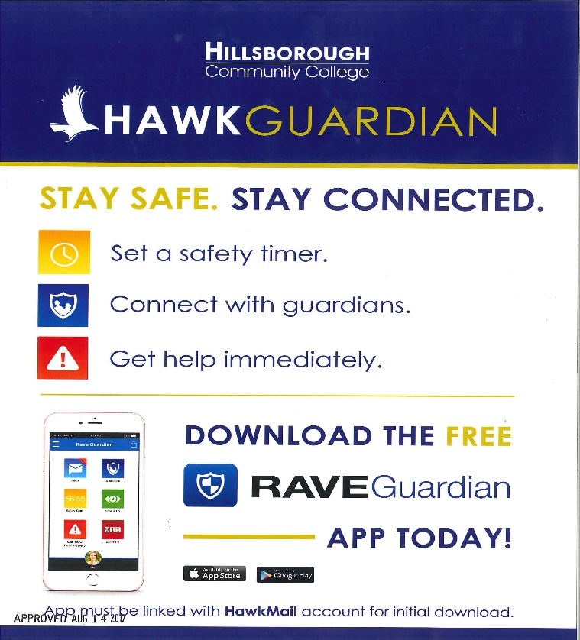

Reporting to Other Campus Security Authorities
While Hillsborough College prefers that community members promptly report all crimes and other emergencies to HC DPS at 813-253-7911 or 911, we also recognize that some may prefer to report to other individuals or College offices. The Clery Act recognizes certain College officials and offices as “Campus Security Authorities (CSA).” The Clery Act defines these individuals as “officials of an institution who have significant responsibility for student and campus activities, including, but not limited to, student housing, student discipline, and campus judicial proceedings. An official is defined as any person who has the authority and the duty to act or respond to issues on behalf of the institution.”

Hillsborough College has officially designated the following offices as places where campus community members can report crimes:

Official/Title | Name/Location | Phone Number
Dr. Gwendolyn W. Stephenson District Administration Center, 4115 N. Lois Ave, Tampa, Fl 33614
Hillsborough College Department of Public Safety | DPS Headquarters Collaboration Studio, Room 331  1602 N. 15th St., Tampa, Fl 33605 | 813-253-7911
Vice President for Student Services & Enrollment Management | Dr. Ken Ray | 813-253-7045
Executive Director of Human Resources | Ms. Kristen Smuder | 813-253-7180
Executive Director of Title IX Coordinator and Civil Right Compliance | Ms. Annazette Houston | 813-253-7043
Vice President of Administration / CFO | Mr. Greg Rose | 813-253-7007
Brandon Campus 10451 Nancy Watkins Dr., Tampa, Fl 33619
Hillsborough College Department of Public Safety | Student Services Building, Room 105 | 813-253-7911
Dean of Students Services | Nestor Melendez / Student Services Building BSSB Room 212-B | 813-253-7880
Dale Mabry Campus 4001 W. Tampa Bay Blvd., Tampa, Fl 33614 (to include Hawks Landing)
Hillsborough College Department of Public Safety | Social Sciences Building, Room 106 | 813-253-7911
Dean of Student Services | Joseph Bentrovato / Student Services Building Room 240 | 813-253-6066
Plant City Campus 1206 N. Park Rd., Plant City, Fl 33563
Hillsborough College Department of Public Safety | Administration Building, Room 108 | 813-253-7911
Dean of Student Services | Yaima Serrano / Student Services Building Room 129 | 813-757-2108
SouthShore Campus 551 24th St. NE., Ruskin, Fl 33570
Hillsborough College Department of Public Safety | Multiple Purpose Facility Room 137 | 813-253-7911
Dean of Student Services | Julie Richardson / Multiple Purpose Facility Room 223E | 813-259-6152
Ybor City Campus 2112 N. 15th St., Tampa, Fl 33605
Hillsborough College Department of Public Safety | Student Services Building, Room 107 | 813-253-7911
Dean of Student Services | John Turner / Student Services Building Room 209 | 813-253-7680
MacDill Educational Center 8102 Condor St., MacDill AFB, Fl 33621
Hillsborough College Department of Public Safety | DPS Headquarters Collaboration Studio, Room 331  1602 N. 15th St., Tampa, Fl 33605 | 813-253-7911
MacDill Manager | Kara Horwood / MacDill Building 223 | 813-259-6392
The Regent 6437 Watson Rd., Riverview, Fl 33578
Hillsborough College Department of Public Safety | Student Services Building (Brandon Campus), Room 105 | 813-253-7911
Regent Manager | Andrew Kovtun / The Regent Room 101 | 813-253-7949
Ybor City Training Center 5610 E. Columbus Dr., Tampa, Fl 33619
Hillsborough College Department of Public Safety | Student Services Building (Ybor Campus), Room 107 | 813-253-7911
VP of Programs | John Meeks | 813-253-7957

Pastoral and Professional Counselors
The Hillsborough College Student Service Department offers a host of personal support services and resources to students at each of the five (5) main campuses. Pastoral and Professional Counselors are available to assist students with a variety of issues in a professional, confidential environment. Their goal is to promote emotional health and wellness among the entire student population.

According to the Clery Act, Pastoral and Professional Counselors are not considered Campus Security Authorities (CSAs) when they are acting in a counseling role; therefore, they are encouraged to inform individuals they are counseling, when they deem it appropriate, of procedures to report crimes on a voluntary, confidential basis for inclusion in the annual disclosure of crime statistics.

Timely Warning Reports – Crime Alerts
Hillsborough College, once notified of a Clery Act defined crime (as detailed below), determines if and how a Timely Warning will be issued. The Clery Act requires that Hillsborough College alert the College community to certain crimes in a manner that is timely and will aid in the prevention of similar crimes. The intent of the Timely Warning is to enable the College community to be as safe as possible. The decision whether to issue a Timely Warning will be made on a case-by-case basis, considering all factors that include the nature of the crime, the continuing danger to the campus community, if any, and whether issuance of the Timely Warning may be made by a team comprised of the Vice President of Student Services, Vice President of Administration, Director of Public Safety, College Counsel, Campus President(s), Executive Director of Marketing/Public Relations, Campus Deans, and the Executive Director of Human Resources.

The Executive Director of Marketing/Public Relations shall draft the contents of the Timely Warning with input from the Director of Public Safety. The issuing of the Timely Warning shall be made by the Executive Director of Marketing/Public Relations. Hillsborough College uses several communication channels for the Timely Warning, including voice and text alerts, email, website banners, social media, digital campus screens, and HawkAlert Mass Notification System.

Emergency Response and Evacuation Procedures

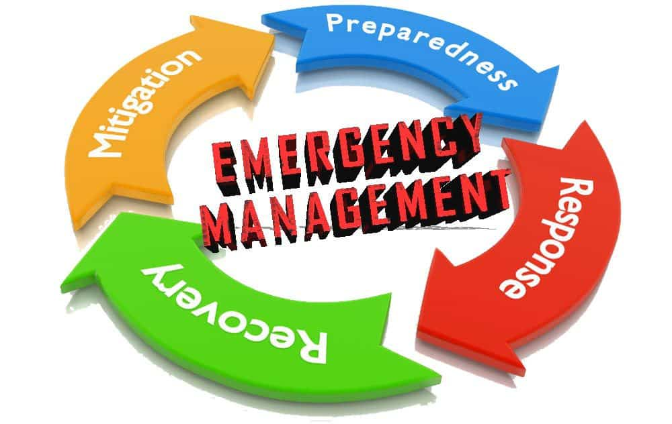

Emergency Management at Hillsborough College
Hillsborough College maintains policies, procedures, and guidelines to respond to emergencies. The College also maintains a revised and updated Continuity of Operations Plan (COOP) and can activate a newly developed Crisis Management Team (CMT), which consists of Executive Leaders representing all essential functions of the College. Moreover, Hillsborough College executed a Statewide Mutual Aid Agreement (SMAA) for assistance during major incidents.

Drills, Exercises, and Training
Hillsborough College tests emergency response and reviews evacuation procedures. These tests include regularly scheduled drills, exercises, and appropriate follow-up activities, designed for assessment and evaluation of emergency plan capabilities. At various times per year, the College advertises its emergency response procedures to the College community through seminars, email, and other publications, and at least once in conjunction with a test of its emergency response and evacuation procedures. The DPS initiated new Active Assailant Response Training through IACLEA certified instructors during the fall 2024 semester.

Emergency Notification
Hillsborough College is committed to ensuring the campus community receives timely, accurate, and useful information in the event of a significant emergency or dangerous situation on property or in the local area that poses an immediate threat to the health and safety of the College community.

Upon DPS confirming that a significant emergency or dangerous situation exists involving an immediate threat to the health and safety of students or employees on or near the College, an Emergency Notification shall be issued. The Emergency Notification may be issued to the entire College community or to a specific segment of the College community, such as an individual campus.

If, in the judgment of the public safety supervisor, an Emergency Notification needs to be issued, the public safety supervisor has the authority to activate the Hawk Alert mass notification system. If, in the professional judgment of the public safety supervisor, issuing an Emergency Notification may compromise efforts to assist a victim or to contain, respond to, or otherwise mitigate the emergency, a notification may not be issued. Hillsborough College may use the Hawk Alert mass notification system (which may include voice and text alerts, email blasts, website banners, social media messages, and digital screen scrolling messages).

Security of and Access to College Facilities
Hillsborough College is a public institution that provides open access to all common areas of the College.
Most campus buildings and facilities are accessible to members of the College community, guests, and visitors during normal hours of business, Monday through Friday, and for limited designated hours on weekends and holidays. Access hours for academic buildings are based on the needs of the academic departments. Faculty and staff offices are not open to the public without an appointment and/or escort. The DPS provides routine, random patrols of all nonresidential College facilities 24 hours per day. Many areas of the College with limited access require a key or card swipe access. Card swipe access is monitored and recorded.

Special Considerations for Hawks Landing Housing Access
The Hillsborough College Foundation provides student housing at the Hawks Landing Complex through a management contract with Peak Campus Management. A private contract security agency provides 24/7 security coverage for the property. Students and staff must present Identification cards to access the property, and entrances are controlled by card access. All visitors must register with the desk attendant at the “Town Hall” before being admitted to the property and must always be escorted by their host. Students have a key that allows access to their own room. Additionally, there are surveillance cameras located on the property in public areas to deter crime and help ensure the safety of all who reside or visit the complex. Hillsborough College also contracts the City of Tampa Police Department at various times to add an extra layer of security presence for residents at the Hawks Landing Complex.

Sexual Misconduct and Title IX
Hillsborough College has designated the Title IX and Civil Rights Compliance employees to coordinate and ensure compliance with Title IX of the Education Amendments of 1973 (20 U.S.C § 1681), which is an all-encompassing federal law that prohibits discrimination based on sex in the educational programs of activities operated by a recipient of federal financial assistance. Sexual harassment of students, which includes acts of sexual violence, including sexual assault, is a form of discrimination prohibited by Title IX.

After an investigation, if it is determined that discrimination or harassment has occurred, the College will undertake appropriate action. Hillsborough College Administrative Rules 6HX-10-2.14 & 6HX-10-2.15, as well as Administrative Procedures 2.03 & 2.05, define its policy prohibiting discrimination and harassment and its procedures for investigating and addressing such complaints, to include providing a complaint or grievance process.

Ms. Annazette Houston, Executive Director of Title IX and Civil Rights Compliance, is the contact person for all Title IX and Discrimination complaints. She can be reached at 813-253-7043 or ahouston14@hccfl.edu. Her office is located at the District Administration Center building, Room 309, 4115 N. Lois Ave., Tampa, Florida 33614. Additional valuable information is available on the College’s Title IX homepage: Title IX | Hillsborough Community College.

Sexual Misconduct Prevention and Response

Introduction
Hillsborough College is committed to creating and maintaining an environment in which all people who participate in Hillsborough College programs and activities can be in an atmosphere free of all forms of harassment, exploitation, or intimidation. The College seeks to create an educational community in which the greatest academic potential of students and the professional potential of employees may be realized. Sexual harassment, sexual assault, sexual battery, sexual coercion, sexual abuse, gender-based harassment, stalking (including cyber-stalking), domestic violence, and dating violence are all forms of gender-based misconduct, which can occur between strangers or acquaintances, including people involved in an intimate or romantic relationship. Sexual violence, as defined by the Office of Civil Rights (OCR), refers to physical sexual acts perpetrated against a person’s will or where a person is incapable of giving consent (due to the student’s age, use of drugs/alcohol, or because of an intellectual or other disability that prevents the student from having the capacity to give consent). Employees, students, or third parties can carry out sexual violence. All acts of sexual violence are forms of sex discrimination and are prohibited by Title IX.

Every member of the Hillsborough College community should be aware that such behavior is prohibited by law and by Hillsborough College policy, and that Hillsborough College will not tolerate sexual misconduct in any form. The College will take appropriate action to correct and discipline behavior that is found to violate College policy or regulations prohibiting any form of sexual misconduct. This policy applies to all members of the College community, including students, employees, volunteers, independent contractors, visitors, and any individual regularly or temporarily employed, studying, living, visiting, conducting business, or having any official capacity at the College. Furthermore, this policy applies to conduct occurring on Hillsborough College property or at college-sanctioned events or programs that take place off campus, including study abroad and internship programs, as well as at Hawks Landing. Hillsborough College is committed to providing a safe learning and working environment, and in compliance with federal law has adopted policies and procedures to prevent and respond to 17 incidents of sexual violence, including sexual assault, domestic violence, dating violence, and stalking. These guidelines apply to all students, faculty, staff, contractors, and visitors. Hillsborough College’s policy on Sexual Harassment can be found at: Harassment, Including Sexual Harassment: 6HX-10-2.11 | HCC.

Reporting an Incident
According to the Office of Civil Rights, “all recipients of federal financial assistance must designate at least one employee to coordinate their efforts to comply with and carry out their responsibilities under Title IX and must notify all students and employees of the designated employee’s contact information.” Hillsborough College meets this requirement with a full-time Compliance and Title IX Officer, who reports directly to the Executive Director of Title IX and Civil Rights Compliance. Ms. Annazette Houston, who reports directly to the College President, fulfills this role. If a student, employee, or visitor has been the victim of an incident of sexual violence, they should immediately report it to Hillsborough College Department of Public Safety by calling (813) 253-7911 or by contacting the Title IX Coordinator by calling 813-253-7043 or emailing TitleIX@hccfl.edu. In the case of an emergency or ongoing threat, if possible, get to a safe location and report the incident to law enforcement by calling 911 or to any of the following agency non-emergency phone numbers:

- Tampa Police Department at 813-231-6130 (Collaboration Studio, Dale Mabry Campus, District Administration Center, or Ybor City Campus).
- Hillsborough County Sheriff’s Office at 813-247-8200 (Brandon Campus, the Regent Center, South Shore Campus, or Ybor City Training Center).
- Plant City Police Department at 813-757-9200 (Plant City Campus).
- Air Force Security Forces at 813-828-3322 (MacDill Education Center).

Reports of all domestic violence, dating violence, sexual assault, and stalking made to the Hillsborough College Public Safety Department will automatically be referred to the Title IX Coordinator for investigation, regardless of whether the complainant chooses to pursue criminal charges.

Hillsborough College officials will assist any victim in notifying law enforcement if they elect to do so. Any student or employee who reports an incident of sexual violence, whether the offense occurred on or off campus, shall receive a written explanation of their rights and options. This written explanation identifies existing counseling, health, mental health, victim advocacy, legal assistance, visa and immigration assistance, and other services available for victims, both within the institution and in the community; and describes options for available assistance in; and how to request changes to academic, living, transportation, and working situations or protective measures. The institution must make such accommodations or provide such protective measures if the victim requests them and if they are reasonably available, regardless of whether the victim chooses to report the crime to public safety or local law enforcement.

State of Florida Crime Definitions
Under Florida Law, the Clery Act crimes of domestic violence have the following definitions:

Domestic Violence – is the use of physical violence, coercion, threats, intimidation, isolation, and stalking, or other forms of emotional, sexual, or economic abuse directed towards a partner in an intimate or romantic relationship, constitutes intimate partner violence. This includes any behaviors that intimidate, manipulate, humiliate, isolate, frighten, terrorize, coerce, threaten, blame, hurt, injure, or wound someone. Domestic violence, as defined by Section 741.28, Florida Statutes, is any assault, aggravated assault, battery, aggravated battery, sexual assault, sexual battery, stalking, aggravated stalking, kidnapping, false imprisonment, or any criminal offense resulting in physical injury or death of one family or household member by another family or household member.

Dating Violence – as defined by Section 784.046, Florida Statutes, is violence between individuals who have or have had a continuing and significant relationship of a romantic or intimate nature. The existence of the relationship is determined by a relationship that existed within the past six (6) months: the nature of the relationship was characterized by an expectation of affection or sexual involvement between the parties; and the frequency and type of interaction between the parties included their involvement over time and on a continuous basis.

Rape/Sexual Assault – is physical sexual acts perpetrated against a person’s will or where a person is incapable of giving consent (due to a person’s age, use of drugs/alcohol or because of an intellectual or other disability):

- by the use or threat of force or coercion
- without effective consent
- where that individual is incapacitated

Sexual assault includes non-consensual sexual contact and sexual intercourse. Sexual assault as defined by Section 784.046, Florida Statutes, includes any forcible felony whenever a sexual act is committed or attempted. Sexual battery as defined by Section 794.011, Florida Statutes, means oral, anal, or vaginal penetration by or union with the sexual organ of another or the anal or vaginal penetration of another by any object (exception for a bona fide medical device).

Fondling – is defined by Chapter 800, Florida Statutes, as Lewdness, an unnatural and lascivious act with another person.

Incest – is defined by Section 826.04, Florida Statutes, as whoever knowingly marries or has sexual intercourse with a person to whom he or she is related by lineal consanguinity, or a brother, sister, uncle, aunt, nephew, or niece commits incest, which constitutes a felony of the third degree.

Statutory Rape – is defined as Sexual Battery pursuant to Section 794.05, Florida Statutes, and includes unlawful Sexual Activity with certain minors, as a person 24 years of age or older who engages in sexual activity with a person 16 years of age commits a felony.

Stalking – is a course of conduct directed at a specific person that would cause that person to feel fear. Stalking involves repeated and continued harassment made against the expressed wishes of another individual, which causes the targeted individual to feel emotional distress, including fear and apprehension. Stalking behaviors may include pursuing or following; non-consensual (unwanted) communication or contact, including face-to-face, telephone calls, voice messages, electronic messages, web-based messages, text messages, unwanted gifts, etc.; trespassing; and surveillance or other types of observation. Stalking, as defined by Section 784.048, Florida Statutes, is any person who willfully, maliciously, and repeatedly follows, harasses, or cyber-stalks another person.

Consent – is a voluntary agreement to engage in sexual activity. Someone who is incapacitated cannot consent. Past consent does not imply future consent. Silence or an absence of resistance does not imply consent; consent to engage in sexual activity with one person does not imply consent to engage in sexual activity with another; consent can be withdrawn at any time; and coercion, force, or threat invalidates consent. Consent as defined by Section 794.011, Florida Statutes, as relates to sexual activity, means intelligent, knowing, and voluntary consent and does not include coerced submission. Consent does not mean or should be construed to mean the failure by an alleged victim to offer physical resistance to the offender or person accused of a sexual assault.

On & Off-Campus Resources

On-Campus Resources:
- The College does not provide any of the following services on campus: Professional Counseling, Health, Mental Health, Victim Advocacy, Legal Assistance, or Visa & Immigration Assistance.

Off-Campus Resources:
- Student Assistance Program 1-800-878-5470 or 24 hour Help
  - Student Assistance Program
- Brandon Regional Hospital 119 Oakfield Dr. Brandon, FL
- Dale Mabry St Joseph’s Hospital 3003 W Dr. Martin Luther King Blvd. Tampa FL
- Plant City South Baptist Hospital 301 N Alexander St. Plant City, FL
- South Shore St. Joseph Hospital South 6901 Simmons Loop, Riverview FL
- Ybor/MacDill/YCTC Tampa General Hospital 1 Tampa General Circle Tampa, FL
- Victim Advocacy Crisis Center of Tampa Bay 211 or 813-234-1234
- Legal Assistance Bay Area Legal Services 1- 800-625-2257
- Visa & Immigration Assistance US Citizenship & Immigration Service
  - Home | USCIS

Accommodations
Whether or not a student or employee reports to law enforcement and/or pursues any formal action, if they report an incident of sexual violence, Hillsborough College is committed to providing them with a safe learning or working environment. Upon request, Hillsborough College will make any reasonably available change to a victim’s academic, living, transportation, and/or working situation. Students may contact the Title IX Coordinator or the appropriate campus Dean of Student Services for assistance:

Title / Campus(es) | Name | Location | Phone Number
Title IX Coordinator | Annazette Houston | District Administration Center, Room 309 | 813-253-7043
Brandon Campus  The Regent | Nestor Melendez | Brandon Campus, Student Services Building, Room 212-B | 813-253-7880
Dale Mabry Campus  Hawks Landing Student Apt | Joseph Bentrovato | Dale Mabry Campus, Student Services Building, Room 246 | 813-259-6006
Plant City Campus  MacDill Center | Yaima Serrano | Plant City Campus, Student Services Building, Room 129 | 813-727-2108
SouthShore Campus | Julie Richardson | SouthShore Campus, Multipurpose Facility Building, Room 134 | 813-259-6152
Ybor City Campus  Ybor City Training Center | John Turner | Ybor City Campus, Student Services Building, Room 209 | 813-253-7680

Employees may report an incident to the Executive Director of Human Resources at 813-253-7180 or Room 110 or to the Title IX and Civil Rights Compliance office at 813-253-7153 or Room 309-B of the District Administrative Office located at 4114 N. Lois Ave., Tampa, FL 33614.

Under Florida law, a victim has the right to go to court and file a petition requesting an Injunction for Protection. Hillsborough College recognizes orders of protection for any person who obtains an order of protection from any reciprocal state (F.S. 741.315, all US States, the District of Columbia, an Indian tribe, or a commonwealth, territory, or possession of the United States). A copy of the order of protection should be provided to the Hillsborough College Public Safety Office on any campus and the Title IX Coordinator and Civil Rights Compliance office, located at 4115 N. Lois Ave, Tampa, FL 33614, Room 309. A complainant may then meet with Hillsborough College Public Safety, the appropriate campus Dean of Student Services, or Executive Director of Human Resources, and the Title IX Coordinator to develop a Safety Action Plan, which is a plan for Hillsborough College and the victims to reduce risk of harm while on campus or coming and going from campus. This plan may include, but is not limited to escorts, special parking arrangements, changing classroom location, or allowing a student to complete assignments from home, etc. The College cannot apply for a legal order of protection, no contact order, or restraining order for a victim from the applicable jurisdiction(s). The victim is required to apply directly for these services through the Clerk of the Circuit Court.

The College may issue an institutional No Contact Order, if deemed appropriate, or at the request of the victim or accused. To the extent of the victim’s cooperation and consent, College offices will work cooperatively to ensure that the complainant’s health, physical safety, work, and academic status are protected, pending the outcome of a formal college investigation of the complaint. For example, if reasonably available, a complainant may be offered changes to academic, living, or working situations in addition to counseling, health services, visa and immigration assistance, and assistance in notifying appropriate local law enforcement.

Victim Confidentiality
Hillsborough College recognizes the sensitive nature of sexual violence and is committed to protecting the privacy of any individual who reports an incident of sexual violence. Personal identifiable information about the victim will be treated as confidential and only shared with persons with a specific need to know who are investigating/adjudicating the complaint or delivering resources for support services to the complainant (for example, publicly available record-keeping for purposes of Clery Act reporting and other disclosures will be made without inclusion of identifying information about the victim, as defined in 42 USC 1395 (a) (20)). Additionally, the institution will maintain as confidential any accommodations or protective measures provided to the victim to the extent that maintaining such confidentiality would not impair the ability of the institution to provide the accommodations or protective measures.

The College does not publish the names of crime victims or house identifiable information regarding victims in the College's public safety department’s Daily Crime and Fire Log or online. Victims may request that directory information on file be removed from public resources by request to the office of the Vice President for Student Services and Enrollment Management at 813-253-7021.

Bystander Intervention and Risk Reduction
Bystanders play a critical role in the prevention of sexual and relationship violence. They are “individuals who observe violence or witness conditions that perpetuate violence. They are not directly involved but have the choice to intervene, speak up, or do something about it.” We want to promote a culture of community accountability where bystanders are actively engaged in the prevention of violence without causing further harm. We may not always know what to do, even if we want to help. It is important to understand and use techniques for safe bystander intervention.

The Five Steps of Bystander Intervention (adapted by Darley & Latane model of helping)
- Notice the event - Recognize that something is amiss or an emergency situation exists. If you see someone who looks like they can be in trouble or needs help, ask if they are okay.
- Interpret the situation as an emergency – Determine that the event is not normal and requires immediate attention.
- Assume personal responsibility – Feel a personal obligation to act and help the victim. Speak up when someone discusses plans to take advantage of another person.
- Decide how to act - Determine the form of assistance to provide (see bystander intervention techniques).
- Take Action – Implement the chosen form of assistance to help the person in distress. Decide how to safely intervene.
Bystander Intervention Techniques
- Distract – aim to subtly intervene without directly confronting the harasser.
  - Create a commotion, engage in a conversation.
- Delegate – Seek assistance from others to intervene.
  - Ask a friend or colleague to step in, find a manager or security officer.
- Document – Record details of what happened.
  - Write down notes or record details on a phone. This may be used later to recall certain details.
- Delay – Wait for the appropriate time to intervene.
  - Once the situation de-escalates it may be more appropriate to intervene. This may allow you to minimize danger but check on the victim’s well-being.
- Direct – Confronting the harasser or situation openly.
  - Addressing the situation, saying “That’s not okay” or “leave them alone.”

When you sense danger or even feel something is potentially dangerous, dial 911. This could be when a person is yelling at or being physically abusive towards another, and it is not safe for you to interrupt.

Education & Awareness Programs
Throughout the year, programs designed to promote awareness are presented by a variety of college resources. Prevention programs include an overview of the College’s policies and procedures, relevant definitions, including prohibited conduct, discussion of the impact of alcohol and illegal drug use, effective consent, safe and positive options for bystander intervention, and information about risk reduction. Incoming students and new employees will receive primary prevention and awareness programming as part of their orientation. Returning students and employees will receive information on a periodic basis. Hillsborough College’s Title IX Coordinator will coordinate the education and prevention calendar and provide programming to campus needs and climate in conjunction with the Campus Dean of Student Services/Hillsborough College Human Resources Department. All educational programs include a review of resources and reporting options available for students, faculty, and staff. As part of the “Violence Against Women Reauthorization Act of 2013” and the Clery Act, educational programs at Hillsborough College are required to include:
- Primary prevention and awareness programs for new students and new employees, including safe and possible options for intervention for bystanders:
  - A statement that Hillsborough College prohibits the offense of domestic violence, dating violence, sexual assault, and stalking;
  - The definition of domestic violence, dating violence, sexual assault, and stalking under Florida law;
  - The definition of consent under Florida Law, in reference to sexual activity;
  - Safe and positive options for bystander intervention that may be carried out by an individual to prevent harm or intervene when there is a risk of domestic violence, dating violence, sexual assault, stalking, or any form of sexual misconduct against a person;
  - Information on risk reduction to recognize warning signs of abusive behavior and how to avoid potential attacks; and
  - Ongoing prevention and awareness programs for Hillsborough College’s students, faculty, and staff.
- Training for the Title IX Coordinator, Public Safety Officers, Hillsborough College designated “Responsible Employees,” victim advocates, and other staff involved with responding to, investigating, or adjudicating sexual misconduct will be conducted annually.

Conduct Proceedings
Hillsborough College strictly prohibits all acts of sexual assault, domestic violence, dating violence, and stalking. In addition to facing criminal action, any student found responsible for violating the policy on sexual misconduct is subject to the Code of Student Conduct and Disciplinary Procedures and may be subject to disciplinary sanctions ranging from probation to expulsion, depending on the incident. Hillsborough College reserves the right to broaden or lessen any range of disciplinary sanctions depending on the circumstances of each case. Hillsborough College will determine the appropriate corrective action.
All conduct proceedings, whether the conduct is reported to have occurred on or off campus, shall provide a prompt, fair and impartial investigation and resolution by officials who have received annual training on the nature of the types of cases they are handling, on how to investigate, and how to conduct a hearing in a manner that protects the safety of victims and promotes accountability. Determination of responsibility shall be made by the Dean of Student Services or the Executive Director of Human Resources using the preponderance of the evidence standard (which means that it is more likely than not that the alleged misconduct occurred).
In all proceedings, including any related meetings, both the accused and accuser are entitled to the same opportunities to have others present, including the right to be accompanied by an advisor of their choice, although Hillsborough College may establish rules on the participation by the advisor. Both the accuser and accused shall simultaneously be informed in writing of the outcome made by the Dean of Student Services or the Executive Director of Human Resources of procedures for appealing the results of the outcome, of any change to the results that occur before the time that they become final, and when such results become final. Disclosure of the outcome shall be made to both parties unconditionally, and each shall be free to share or not share the details with any third parties. For additional information about student conduct proceedings, please consult the Code of Student Conduct available at: Student Handbook | Hillsborough Community College
For additional information about employee conduct proceedings, please consult Hillsborough College’s Administrative Procedures on discipline/applicable collective bargaining agreement available at: Administrative Rules and Procedures | HCC

Students
Sanctions or interventions may include, but are not limited to, one or more of the following:
- Formal Reprimand: A formal notice that the student has violated college policy and those future violations may be dealt with more severely.
- Disciplinary Probation: A designated period during which the student is not in good standing with the College. The terms of probation may involve restrictions of student privileges and/or set specific behavioral expectations.
- Restitution: Reasonable and limited compensation for loss, damage, or injury to the appropriate party in the form of money or material replacement.
- Restriction from Employment at the College: Prohibition of or limitation on Hillsborough College employment.
- Class/Workshop/Training/Program Attendance: Enrollment in and completion of a class, workshop, training, or program that could help the student.
- Educational Project: Completion of a project specifically designed to help the student understand why certain behavior was inappropriate and to prevent its recurrence.
- Hawks Landing Housing Transfer or Removal: Placement in another room or housing unit or removal from Hawks Landing housing complex. Housing transfers or removals may be temporary or permanent, depending on the circumstances.
- Professional Assessment: Completion of a professional assessment that could help the student or the College ascertain the student’s ongoing supervision or support needs to successfully participate in the Hillsborough College community.
- Removal from Specific Courses or Activities: Suspension or transfer from courses or activities at the College for a specified period.
- No Contact: Restriction from entering specific areas and/or from all forms of contact with certain people.
- Suspension: Separation from the College for a specified period or until certain conditions are met.
- Expulsion: Permanent separation from the College.
- In addition to the sanctions/interventions applied to students found responsible for sexual misconduct, the College may find it helpful or necessary to request or require others to undertake specific steps designed to eliminate misconduct, prevent its recurrence, or remedy its effects. Examples include, but are not limited to, the following:
  - Requesting or requiring a college department to conduct training for its staff or members;
  - Making involved parties aware of academic support services available;
  - Making involved parties aware of counseling or medical services available;
  - Arranging, where possible, for a party to re-take or withdraw from a course without penalty; and
  - Revising College policies, procedures or practices when necessary.

Faculty/Staff
Any employee found responsible for violating the policy prohibiting sexual misconduct may be subject to disciplinary action up to and including termination. Hillsborough College reserves the right to broaden or lessen any range of disciplinary sanctions depending on the circumstances of each case.

Personal Safety
Theft, disorderly conduct, and alcohol related offenses are very common on college campuses. However, they don’t stand alone. Despite law enforcement’s efforts, serious crimes do occur on campuses. It is important to report any suspicious incidents to Hillsborough College DPS (813-253-7911) or local law enforcement and always remain alert and vigilant.

Hillsborough College actively participates in efforts to educate the campus community about crime awareness and personal safety. The Department of Public Safety is committed to providing a safe learning and work environment for all students and employees. Public Safety personnel are present at all campuses and provide support to all college locations. Personal safety tips are available for all students and employees.

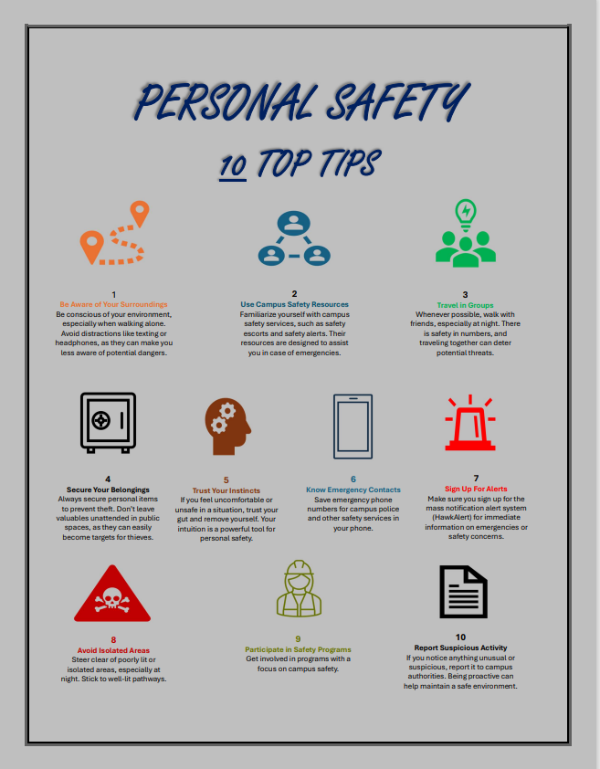

Rape and Sexual Assault Victim Information
Sexual assault and any attempt to commit sexual assault are serious criminal offenses that will not be tolerated by Hillsborough College. The term "sexual assault," although not a specific criminal offense in violation of the Florida Criminal Code, is commonly used to include criminal offenses such as sexual battery, sexual abuse, sexual misconduct, severe types of sexual harassment, and other offenses of this nature, including instances of assault and battery. Hillsborough College maintains a separate administrative rule and procedure on sexual harassment. In the event a determination is made that the incident involved only sexual harassment allegations, the incident will immediately be referred to the Title IX and Civil Rights Compliance Office in accordance with the appropriate administrative rule and procedure on sexual harassment.
A sexual assault incident or attempted sexual assault, either on college property, on adjacent property, or at a college-sponsored or related event, will be immediately reported to a local law enforcement agency and/or Hillsborough College DPS (813-253-7911). College staff will assist and cooperate fully with the investigation. Sexual assault incidents will be uniformly handled by the College in a confidential manner to the extent allowed by law and in accordance with the administrative procedure.
Victims of sexual assaults often have difficulty reporting a sexual assault for various reasons, such as knowing the perpetrator, fear of retaliation, fear of parents learning about the incident, and fear of getting in trouble with law enforcement. Despite these concerns, it is vital to report such incidents in order to get help and prevent the perpetrator from repeating their crime. The only person responsible for committing an act of Sexual Assault is the perpetrator.
If a victim of a sexual assault does not wish to make a report to law enforcement, he or she is still encouraged to seek professional medical advice and counseling. Please note that all healthcare providers are legally required to report all cases of suspected sexual or physical assault to law enforcement.

Guidance For Victims of Sexual Assault

Victims of sexual assault are strongly encouraged to take the following steps:
- Ensure your own safety - Get to a safe place as soon as possible and prioritize your safety and well-being.
- Reach out for support – Find a person you trust to confide in and receive emotional support. If you wish to express your experience and emotions anonymously, victims are encouraged to contact a crisis hotline such as About the National Sexual Assault Telephone Hotline | RAINN
- Seek medical attention – Preferably from a specially trained sexual assault nurse examiner (SANE) for a forensic exam. A sexual assault forensic exam can be used to collect DNA, blood samples and other evidence. An exam may also reveal the presence of physical injury of which the victim is unaware.
- Preserve evidence – Avoid bathing, showering, brushing teeth, douching, toilet usage, or changing clothing until after an examination. Advocates are available to victims for support.
- Contact police – Sexual assault is a crime. Notifying police allows them to conduct a thorough investigation and identify the suspect to prevent them from harming the victim again or others. The decision to contact the police or to prosecute is a choice for the victimized person.
- Seek mental health support – Care from a professional counselor can be beneficial for processing trauma and emotions after an assault and begin the process of recovery. Options are available for free.

Our Commitment to Addressing Sexual Assault/Rape
The College does not tolerate sexual misconduct or abuse, such as sexual assault, rape, or any other form of nonconsensual sexual activity. Sexual misconduct in any form violates the Code of Student Conduct, College policies, and may violate Federal and State Laws. Violations of this policy are subject to disciplinary sanctions through the Dean of Student Services or the Executive Director of Human Resources Office. All sexual assault victims have the following rights:

- Both parties may have others present during the disciplinary proceeding and any related meetings, including an advisor or support person of their choice. This person is not entitled to represent the person.

- A complainant has the right to present his or her case. This includes the right to adequate, reliable, and impartial investigation of complaints, the right to have an equal opportunity to present witnesses and other evidence, and the right to the same appeal processes for both parties.

- A complainant has the right to be notified of the time frame within which: (a) the College will conduct a full investigation of the complaint; (b) the parties will be notified of the outcome of the complaint; and (c) the parties may file an appeal, if applicable.

- A complainant has the right for the complaint to be decided using a preponderance of the evidence standard (i.e., it is more likely than not that sexual misconduct occurred).

- Both parties have the right to be notified, in writing, of the outcome of the disciplinary proceedings at the same time.

- As noted in the Clery Act, both parties are to be informed of the outcome, including sanction information, of any institutional proceeding alleging a sex offense. Hillsborough College may not require a complainant to abide by a non-disclosure agreement, in writing or otherwise.

- The grievance procedures may include voluntary informal methods (e.g., mediation) for resolving some types of sexual misconduct complaints. However, the complainant must be notified of the right to end the informal process at any time and begin the formal stage of the complaint process. In cases involving allegations of sexual assault, mediation is not appropriate.

College Procedures for Responding to Reports of Sexual Assault
The victim of a sexual assault has many rights, including:

- The right to report the incident to Hillsborough College DPS, the Title IX and Civil Rights Office or local authorities. Hillsborough College will assist victims in notifying either Hillsborough College DPS or local police. Filing a police report does not mean the victim must pursue criminal charges. The victim maintains his or her rights throughout the process.

- There are several community service and health organizations that can provide counseling, mental health, and other related services to sexual assault victims. Through the Offices of the Dean of Student Services or the Executive Director of Human Resources, students or employees can obtain assistance if requested.

- If a victim of a sexual assault or relationship violence incident requests a change in his or her living arrangements or academic schedule, the Office of Student Services and other offices at the College will assist the individual with making these changes, if they are reasonably available.

College Disciplinary Procedures in Sexual Assault Incidents
Hillsborough College Student Code of Conduct process is designed to afford a complainant (the person who is bringing a charge) and a respondent (the person who is answering a charge) a fair, prompt, and appropriate resolution process. The process is designed to help people who need support as they address these incidents.

The Office of Student Services manages the proceedings in which a student is the alleged perpetrator. The full text of the protocol for how the College responds to sexual assault complaints through the campus conduct process can be obtained from any Dean of Student Services office and the student services web page. The Executive Director of Human Resources is responsible for managing proceedings for those cases in which an employee is the respondent.

In determining whether the alleged conduct constitutes sexual harassment or assault, the full context in which the alleged incident occurred must be considered. In any case, both the complainant and the respondent are entitled to the same opportunities to have others present during any disciplinary proceeding. Both the complainant and the respondent will be informed of the outcome of any proceeding. During any sexual assault complaint proceeding, the College has a range of sanctions available. Those sanctions may range from probation to expulsion from the College, depending upon the nature and circumstances of the specific incident.

Sex Offender Registration – Campus Sex Crimes Prevention Act
In accordance with the “Campus Sex Crimes Prevention Act of 2000,” which amends the Jacob Wetterling Crimes Against Children and Sexually Violent Offender Registration Act, the Jeanne Clery Act, and the Family Educational Rights and Privacy Act of 1974, Hillsborough College is providing contact information to the State of Florida Sex Offender Registry. Federal and state laws require a person designated as a “sexual predator or offender” to register with the Florida Department of Law Enforcement (FDLE). FDLE is required to notify the local law enforcement agency where the registrant resides, attends, or is employed by an institution of higher learning.

Students, faculty, and staff may access information about sexual predators/offenders at: https://offender.fdle.state.fl.us/offender/sops/home.jsf

To conduct a search by College or University: https://offender.fdle.state.fl.us/offender/sops/universitySearch.jsf

FDLE has also established a toll-free number (1-888-FL-PREDATOR) or (1-888-357-7332) that allows the public to request information about Sexual Predators and Sex Offenders living in their communities and around the state.

Hillsborough College Security Policies, Crime Prevention & Safety Awareness Programs
In addition to the many programs offered by the DPS and other College offices, Hillsborough College has established several policies and procedures related to ensuring a reasonably safe campus community. These policies include:

Hillsborough College Threat Assessment Team
Hillsborough College also maintains a Threat Assessment Team (TAT) that immediately assesses threats and behaviors of concern that may impact the College community. The TAT provides an online reporting tool for members of the Hillsborough College community to report behavioral concerns. For more information, refer to:
Speak Up HCC | Hillsborough Community College

Missing Student Notification Policy
The Higher Education Act of 2008 requires institutions that provide on-campus student housing to establish a missing student notification policy and procedure for those who reside in the on-campus housing. Hillsborough College takes student safety very seriously. To this end, the following policy has been established concerning students who live in college-owned campus housing and who, based on the facts along with circumstances known at the time to college officials, are presumed to be missing. Anyone who believes a student to be missing should contact the Department of Public Safety at 813-253-7911, a Student Housing Resident Advisor, or any College official. Any report made to the College will be followed up with an immediate investigation to determine whether the student is missing in cooperation with local law enforcement. The person providing the report to DPS will immediately refer reports made to a Housing Security Officer, Resident Advisor, or any College official.

At the beginning of each semester, students will be asked to provide, on a voluntary basis, emergency contact information, which will be used solely for missing persons’ purposes while the student is enrolled at Hillsborough College. This emergency information will be kept on file by the Assistant to the Dean (Student Life Programs). Contact information shall be updated each semester. The student is responsible for ensuring that the contact information is up to date and accurate.

If a student is determined to be missing and has designated a contact person, the contact person will be notified no later than 24 hours after the determination by DPS or local law enforcement that the student is missing. If a missing student is under the age of 18 and not an emancipated individual, the College is also required to notify the parent or guardian of the missing student no later than 24 hours after the determination by College Public Safety officials or local law enforcement that the student is missing.

The DPS will immediately notify the appropriate local law enforcement agency when the student is determined to be missing. The Dean of Student Services at the Dale Mabry campus or his/her designee will notify the appropriate emergency contact person listed for a missing student.

Most missing person reports in the College environment result from students changing their routines without informing roommates and/or friends of the change. For the purposes of this policy, a student will be considered missing if a roommate, classmate, faculty member, friend, or other person has not seen or heard from the person in a reasonable amount of time. In general, a reasonable amount of time is 24 hours, but it may vary with the time of day and information available regarding the missing person’s daily schedule, habits, and reliability. There is no requirement for the DPS to wait 24 hours to notify local law enforcement of a missing person. Individuals will also be considered missing immediately if their absence has occurred under circumstances that are suspicious or cause concern for their safety.

Daily Crime and Fire Log
The College maintains a public Crime and Fire Log at DPS Headquarters located at the HCC Collaboration Studio, 1602 N. 15th St., Room 331, Tampa, FL 33605. The Crime and Fire Log is available for public inspection (during normal business hours). The log contains all crimes on Hillsborough College Clery reportable property and any fires at Hawks Landing residential facility that have been reported to the DPS. The appropriate information is logged in the Crime and Fire Log within two business days of it being reported. The Crime and Fire Log shall contain the required reporting information for the most recent 60 days. Crime and Fire Log information older than 60 days shall be furnished upon request within 2 business days.

Crime Prevention and Safety Awareness Programs
To promote safety awareness, the DPS maintains a strong working relationship with the community. The DPS regularly conducts crime prevention seminars and presentations at student events, faculty/staff seminars, and in-service trainings. The department also maintains a website with crime prevention information and resources. The DPS conducts escorts to members of the College community as requested. The DPS takes a proactive, visible, and community approach to providing safety and security services.

Hillsborough College Policies Governing Alcohol and Other Drugs

Hillsborough College Alcohol and Drug Policy
The unlawful manufacture, dispensing, possession, or use of controlled substances while at the College or on college property is prohibited. In addition, a student or employee is prohibited from being under the influence of alcohol or having possession of alcoholic beverages while at or on college property. The College will provide full cooperation with local law enforcement agencies for alcohol and drug-related violations. Sanctions may include referral for prosecution, expulsion of a student and termination of an employee, or completion of an appropriate rehabilitation program

Policies Specific to Students
A student who is formally charged with drug violations may also, following an administrative hearing, be suspended until his/her case is adjudicated pursuant to the Student Code of Conduct.

Illegal Substances (Drugs)
It is a violation of state law and college policy to illegally possess, use, distribute, manufacture, sell, or be under the influence of other drugs. Students who violate this policy will be referred to the office of Student Life Programs, the Dean of Student Services, and/or Hillsborough College DPS.

It is unlawful for any person to sell, purchase, manufacture, deliver or possess with the intent to sell a controlled substance in, on or within 1,000 feet of the real property comprising a public or private elementary, middle, secondary school, community or state college or university.

Know the signs (not all inclusive):
- Passed out or difficult to awaken
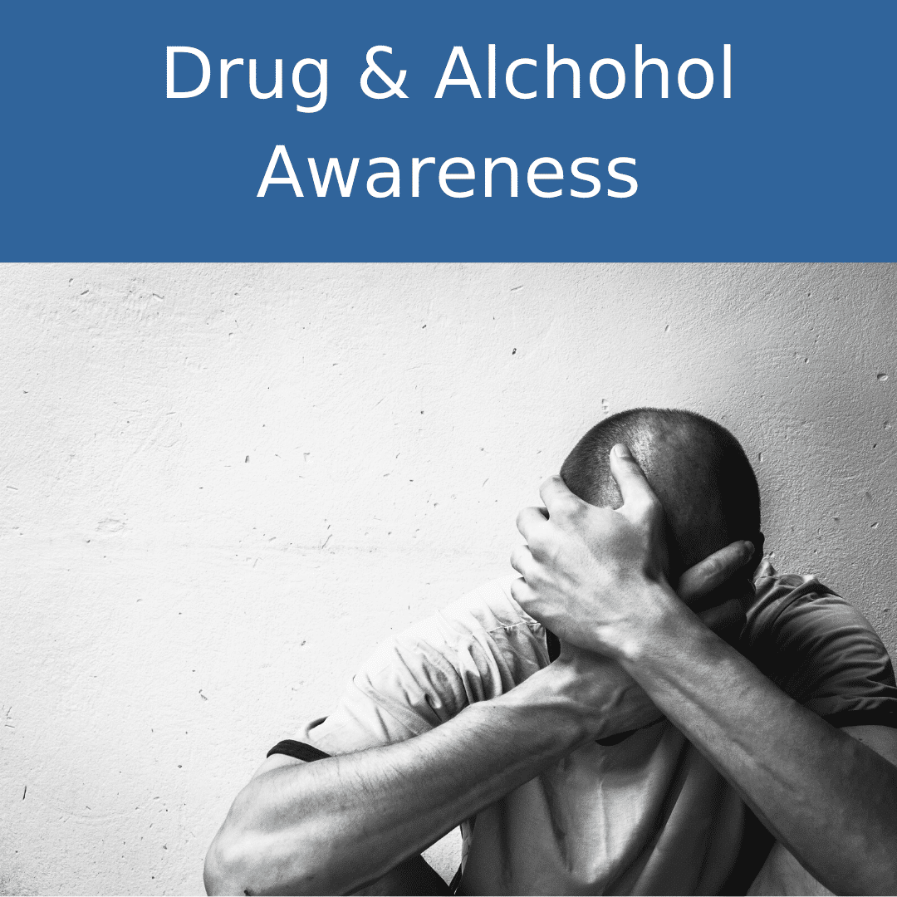
- Cold, clammy, pale, or bluish skin
- Slowed breathing
- Vomiting (asleep or awake)

Know how to help (not all inclusive):
- Turn a vomiting person on his/her side to prevent choking
- Clear vomit from the mouth
- Keep the person awake
- NEVER leave the person unattended

Policies Specific to Faculty and Staff
As a condition of Hillsborough College employment, every employee shall abide by the terms of this policy. Any employee who violates this policy is subject to college disciplinary action, including dismissal, as well as criminal sanctions provided by federal, state, or local laws. An employee may be required to participate in a drug abuse or drug rehabilitation program. An employee must notify his or her supervisor of any criminal drug conviction for a violation occurring in the College workplace no later than five (5) days after such conviction. Please consult Policy 6HX-10-2.05, A Drug-Free Workplace, for more information: Drug-Free HCC Administrative Rules | Hillsborough Community College (hccfl.edu).

Florida’s Alcohol Laws

Drinking Age
The legal drinking age in Florida is 21. Selling, giving, or serving alcohol to people under 21 is unlawful. In Florida, the law extends to possession of alcohol by anyone under 21. It is unlawful for anyone to misrepresent or misstate his/her age. This includes the manufacture or use of false identification. Use of an altered identification for procuring alcohol is a felony.

Open Container Law
It is unlawful for any person to consume or to induce, assist, or aid another to consume any beverage containing more than 1% alcohol by weight upon any street, sidewalk, or in any alley within the City of Tampa. It is unlawful to have an open container of alcohol in a vehicle. Under Florida law, driving under the influence of alcoholic beverages or any controlled chemical substance (DUI) is an offense evidenced by the impairment of normal faculties or an unlawful blood or breath alcohol level of .08 or higher.

Sale or Possession of Illegal Drugs
It is unlawful to be in possession of illicit drugs and/or to sell or intend to sell illicit drugs.

Selling and Purchasing Controlled Substances within 1,000 Feet of School
It is unlawful for any person to sell, purchase, manufacture, deliver, or possess with the intent to sell a controlled substance in, on, or within 1,000 feet of the real property comprising a public or private elementary, middle, secondary school, community, or state college or university.

Annual Disclosure of Crime Statistics
Hillsborough College Public Safety collects the crime statistics disclosed in the charts through several methods. The statistics below also include crimes that are reported to various campus security authorities, as defined in this report. The statistics reported here generally reflect the number of criminal incidents reported to the various authorities. The statistics reported for the subcategories on liquor laws, drug laws, and weapons offenses represented the number of people arrested or referred to campus judicial authorities for respective violations, not the number of offenses documented.

Clery Act Reporting

Criminal Offenses
Murder and Non-negligent Manslaughter - the willful (non-negligent) killing of a human being by another.
Manslaughter by Negligence – the killing of another person through gross negligence.
Sex Assault – any sexual act directed against another person, without the consent of the victim, including instances where the victim is incapable of giving consent.
- Rape – the penetration, no matter how slight, of the vagina or anus with any body part or object, or oral penetration by a sex organ of another person, without the consent of the victim. This offense includes the rape of both males and females.

- Fondling – the touching of the private body parts of another person for the purpose of sexual gratification, without the consent of the victim, including instances where the victim is incapable of giving consent because of his/her age or because of his/her temporary or permanent mental incapacity.

- Incest – non-forcible sexual intercourse between persons who are related to each other within the degrees wherein marriage is prohibited by law.

- Statutory Rape – Sexual intercourse with a person who is under the statutory age of consent.

Robbery – the taking or attempting to take anything of value from the care, custody, or control of a person or persons by force or threat of force or violence and/or by putting the victim in fear.

Aggravated Assault – an unlawful attack by one person upon another for the purpose of inflicting severe or aggravated bodily injury. This type of assault is usually accompanied using a weapon or by means likely to produce death or great bodily harm.

Burglary – the unlawful entry of (or attempt to enter) a structure (defined as 4 walls + roof + door) to commit a felony or theft (excludes vehicle burglary, shoplifting, and thefts from open areas).

Motor Vehicle Theft – the theft or attempted theft of a motor vehicle (motorized vehicle that runs on land intended to transport persons from one place to another - including e-bikes, motor scooters, golf carts, etc.; Includes joyriding).

Arson – any willful or malicious burning or attempt to burn, with or without intent to defraud, a dwelling house, public building, motor vehicle or aircraft, personal property of another, etc.

Hate Crimes

A hate crime is a criminal offense (Clery-reportable crime) that manifests evidence that the victim was intentionally selected because of the perpetrator’s bias against the victim. Categories of bias are race, religion, sexual orientation, gender, gender identity, ethnicity, national origin, and disability. Hate crimes include all Criminal Offenses listed above (except Manslaughter by Negligence), as well as Larceny-Theft, Simple Assault, Intimidation, and Destruction /Damage/Vandalism of Property.

Categories of Bias
- Race - a preformed negative attitude toward a group of persons who possess common physical characteristics genetically transmitted by descent and heredity which distinguish them as a distinct division of humankind.

- Religion – a preformed negative opinion or attitude toward a group of persons who share the same religious beliefs regarding the origin and purpose of the universe and the existence or nonexistence of a supreme being.

- Sexual Orientation – a preformed negative opinion or attitude toward a group of personal based on their sexual attraction toward, and responsiveness to, members of their own sex or members of the opposite sex.

- Gender – a preformed negative opinion or attitude toward a group of persons because those persons are male or female.

- Gender Identity – a preformed negative opinion or attitude toward a group of persons because of the gender identity of those persons.

- Ethnicity – a preformed negative opinion or attitude toward a group of persons of the same race or national origin who share common or similar traits, languages, customs, and traditions.

- National Origin – a preformed negative opinion about a group of persons based upon their being from a particular country or part of the world.

- Disability – a preformed negative opinion or attitude toward a group of persons based on their physical or mental impairments/challenges, whether such disability is temporary or permanent, congenital or acquired by heredity, accident injury, advanced age, or illness.

Additional Hate Crime Criminal Offenses

- Larceny/Theft – the unlawful taking, carrying, leading, or riding away of property from the possession or constructive possession of another. (Constructive possession is the condition in which a person does not have physical custody or possession but is able to exercise dominion or control over a thing.) Classify as Larceny: thefts of bicycles or automobile accessories; shoplifting; pocket-picking; stealing of property not taken by force, violence, or fraud; attempted larcenies.

- Simple Assault – an unlawful physical attack by one person upon another where neither the offender displays a weapon, nor the victim suffers obvious severe or aggravated bodily injury involving apparent broken bones, loss of teeth, possible internal injury, severe laceration, or loss of consciousness.

- Intimidation – to unlawfully place another person in reasonable fear of bodily harm with threatening words and/or other conduct but without displaying a weapon or subjecting the victim to actual physical attack.

- Destruction/Damage/Vandalism or Property (except Arson) – to willfully or maliciously destroy, damage, deface or otherwise injure real or personal property without the consent of the owner or the person having custody or control of it.

Violence Against Women Act (VAWA) Offenses

Domestic Violence - a felony or misdemeanor crime of violence committed by:
- a current or former spouse or intimate partner of the victim;
- a person with whom the victim shares a child in common;
- a person who is cohabitating with, or has cohabitated with, the victim as a spouse or intimate partner;
- a person similarly situated to a spouse of the victim under the domestic or family violence laws of the jurisdiction in which the crime of violence occurred; or
- any other person against an adult or youth victim who is protected from that person’s acts under the domestic or family violence laws of the jurisdiction in which the crime of violence occurred.

Dating Violence - violence committed by a person who is or has been in a social relationship of a romantic or intimate nature with the victim. The existence of such a relationship shall be determined based on:
- the reporting party’s statement, and with consideration of the length of the relationship,
- the type of relationship, and
- the frequency of interaction between the persons involved in the relationship.

Stalking - Engaging in a course of conduct directed at a specific person that would cause a reasonable person to:
- fear for the person’s safety or the safety of others; or
- suffer substantial emotional distress.

Sexual Assault - see under “Criminal Offenses” as primary Clery-reportable crimes.

Arrests and Disciplinary Actions

Weapon Law Violation – The violation of laws or ordinances prohibiting the manufacture, sale, purchase, transportation, possession, concealment, or use of firearms, cutting instruments, explosives, incendiary devices, or other deadly weapons.

Drug Law Violation – The violation of laws prohibiting the production, cultivation, distribution, and/or use of certain controlled substances and the equipment or devices utilized in the preparation and/or use. The unlawful cultivation, manufacture, distribution, sale, purchase, use, possession, transportation, or importation of any controlled drug or narcotic substance.

Liquor Law Violation – The violation of state or local laws or ordinances prohibiting the manufacture, sale, purchase, transportation, possession, or use of alcoholic beverages, not including driving under the influence and drunkenness.

Stop Campus Hazing Act Offense

Hazing - any intentional, knowing, or reckless act committed by a person(s) against another person(s) regardless of the willingness of such other person(s) to participate that:
- is committed in the course of an initiation into, an affiliation with, or the maintenance of membership in, a student organization; and

- causes or creates a risk, above the reasonable risk encountered in the course of participation at the [College] or the organization (such as the physical preparation necessary for participation in an athletic team), or physical or psychological injury, including:

  - whipping, beating, striking, electronic shocking, placing of a harmful substance on someone’s body, or similar activity;

  - causing, coercing, or otherwise inducing sleep deprivation, exposure to the elements,
confinement in a small space, extreme calisthenics, or other similar activity;

  - causing, coercing, or otherwise inducing another person to consume food, liquid, alcohol, drugs or other substances;

  - causing, coercing, or otherwise inducing another person to perform sexual acts;

  - any activity that places another person in reasonable fear of bodily harm through the use of threatening words or conduct;

  - any activity against another person that includes a criminal violation of local, State, Tribal, or Federal law; and

  - any activity that induces, causes, or requires another person to perform a duty or task that involves a criminal violation of local, State, Tribal, or Federal law.

For purposes of reporting incidents of Hazing, a Student Organization means: an organization at an institution of higher education (such as a club, society, association, varsity or junior varsity athletic team, fraternity, sorority, band, or student government) in which two or more of the members are students enrolled at the institution, whether or not the organization is established or recognized by the institution.

Crime Locations (“Clery Geography”)

On-Campus – Buildings and properties that are part of a campus, including any building or property owned or controlled by the College within the same reasonably contiguous geographic area and used by the College in direct support of, or in a manner related to the College’s educational mission. This includes any building or property owned by the College but controlled by another entity and which is frequently used by students and supports institutional purposes.

Non-Campus Property – Buildings and property owned or controlled by officially recognized student organizations, as well as buildings and property located off campus but owned or controlled by the College, frequented by students and used in support of or in relation to the College’s educational purpose.

Public Property – All public property, including thoroughfares, streets, sidewalks, and parking facilities, that is within a campus, or immediately adjacent to and accessible from a campus.

Unfounded

If a reported crime is investigated by law enforcement authorities and found to be false or baseless, meaning that the crime did not occur or was never attempted, the crime is “unfounded”. Only sworn law enforcement personnel may unfound a crime.

Crime Statistics
Notes:
- The City of Tampa Police Department provided statistical data that was essential for our reporting.
- Hillsborough County Sheriff’s Office website provided statistical data essential for reporting.
- The Plant City Police Department provided statistical data that was essential for our reporting.
- Officials at MacDill Air Force Base provided statistical data that was essential for reporting.

Brandon Campus
10451 Nancy Watkins Dr.
Tampa, FL 33619
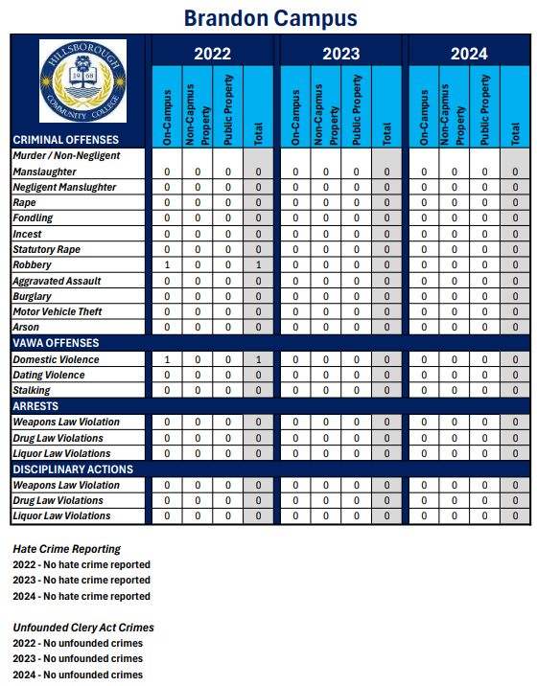

Collaboration Studio
1602 N. 15th St.
Tampa, FL 33605
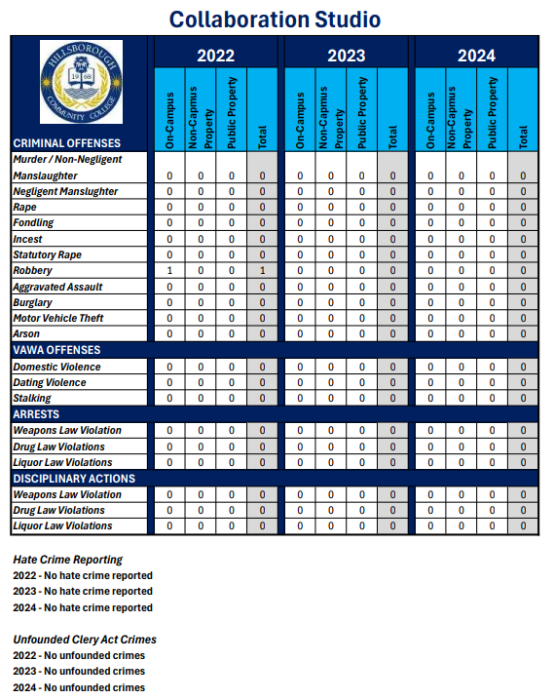

Dale Mabry Campus
4001 Tampa Bay Blvd.
Tampa, FL 33614
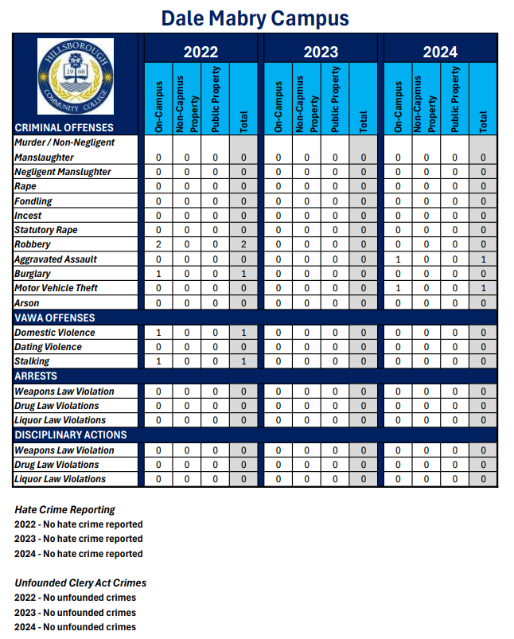

District Administration Center Building
4115 N. Lois Ave.
Tampa, FL 33614

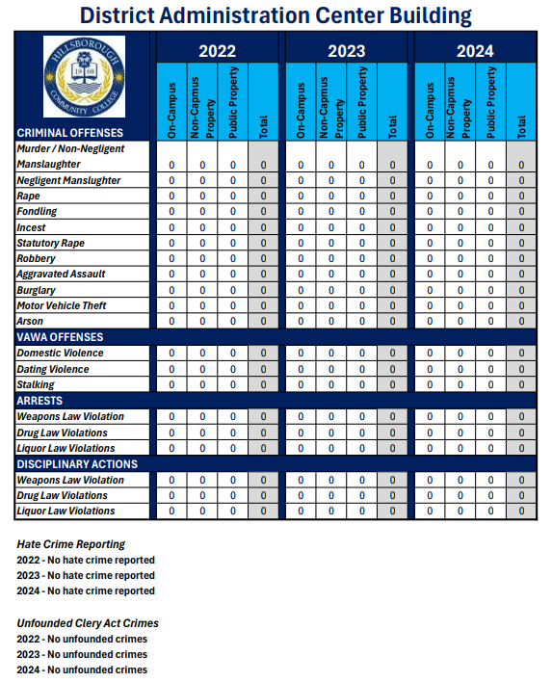

Hawks Landing
4010 N. Lois Ave.
Tampa, FL 33614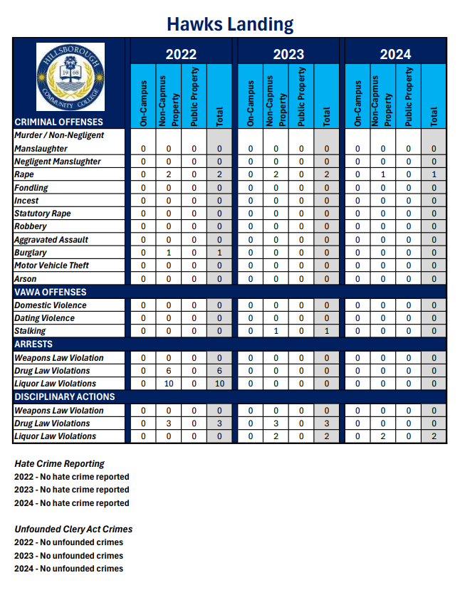

MacDill Center
8102 Condor St.
MacDill Air Force Base, FL 33621
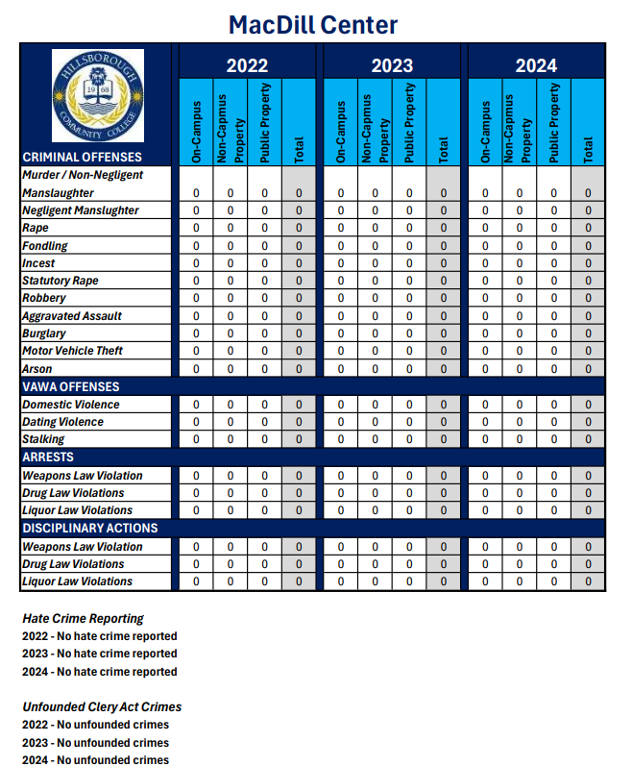

Plant City Campus
1206 N. Park Rd.
Plant City, FL 33563
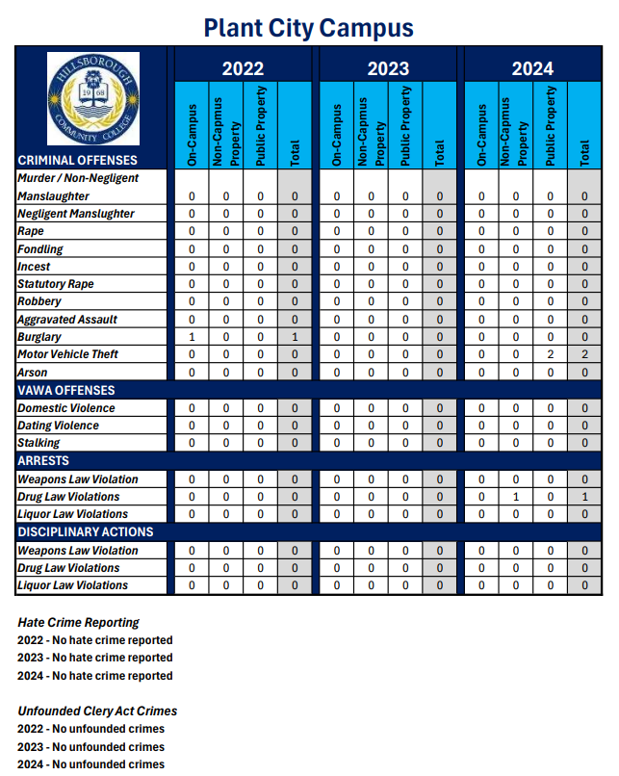

SouthShore Campus
551 24th St. NE.
Ruskin, FL 33570
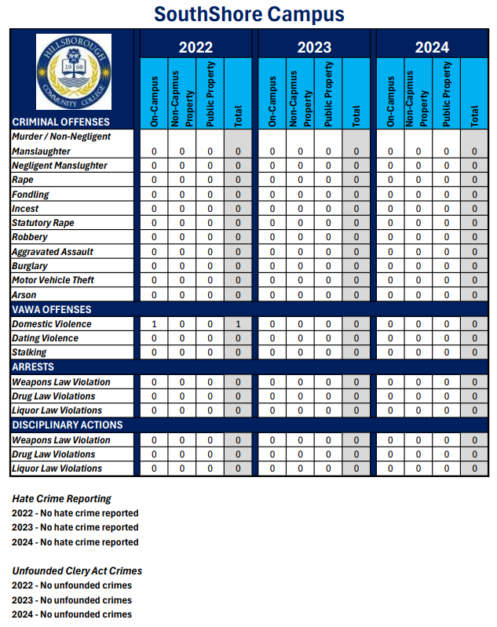

The Regent
6437 Watson Rd.
Riverview, FL 33578
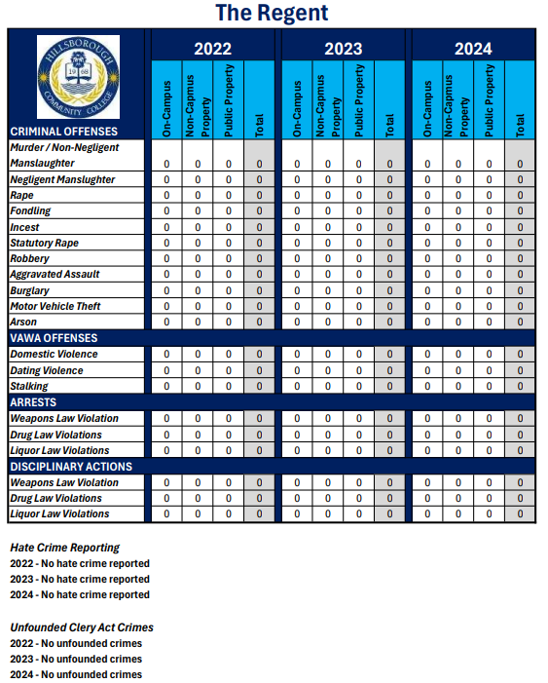

Ybor Campus
2112 N. 15th St.
Tampa, FL 33605
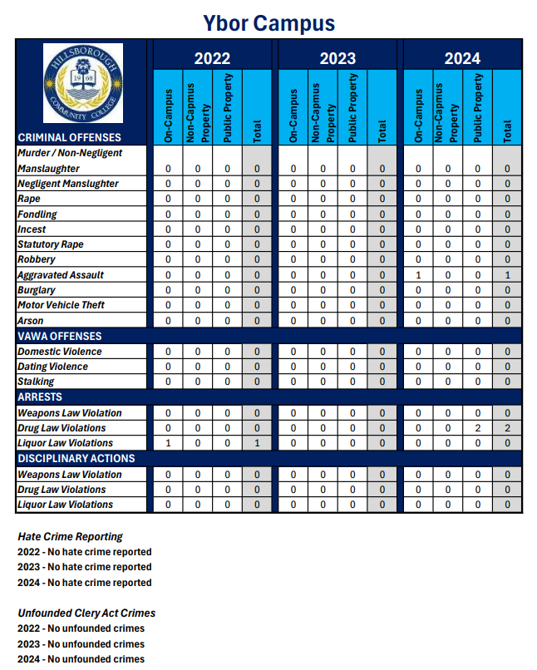

Ybor City Campus Training Center
5610 E. Columbus Dr.
Tampa, FL 33619
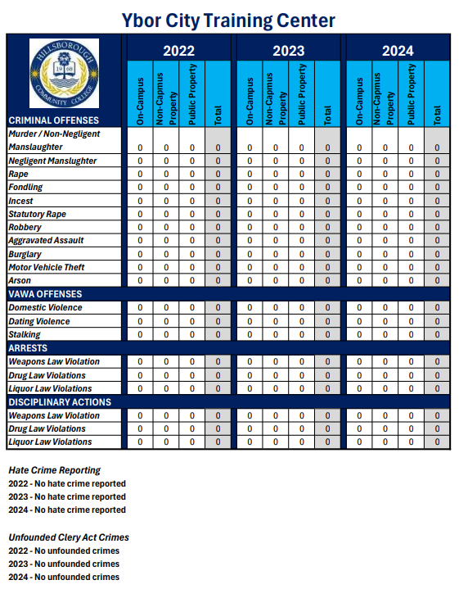

Annual Fire Safety Report

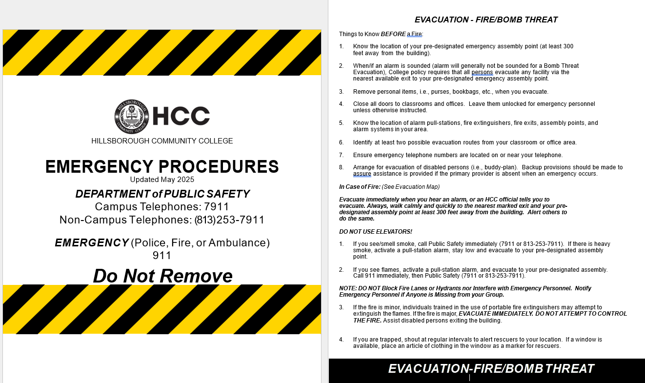

The Higher Education Opportunity Act requires institutions that maintain on-campus student housing facilities to publish an annual fire safety report that contains information about campus fire safety practices and standards of the institution. The following report details all information required by the act for Hillsborough College.

Fire Safety Definitions
The following terms are used within this report. Definitions have been obtained from the Higher Education Opportunity Act:

On-Campus Student Housing – a student housing facility that is owned or controlled by the institution or located on property that is owned or controlled by the institution and is within a reasonable contiguous area that makes up the campus.

Fire – any instance of open flame or other burning in a place not intended to contain the burning or in an uncontrolled manner.

Hawks Landing Residence Fire Drills
Fire drills for the entire Hawks Landing Student Housing Complex are conducted each semester. All occupants and staff are required to vacate the building and report to the assigned marshaling area.

Fire Safety
Hillsborough College takes Fire Safety very seriously and continues to enhance its programs to the College community through education, engineering, and enforcement. Educational programs are presented throughout the year to faculty, staff, and students so they are aware of the rules and safe practices. These programs, which are available at all campus locations, include identification and prevention of fire hazards, actual building evacuation procedures, and drills. In addition, specific occupant response to fire emergencies and hands-on use of fire extinguishers.

Hillsborough College maintains and tests all fire alarms and automatic fire suppression systems in accordance with the appropriate National Fire Protection Association (NFPA) Standard to ensure system readiness and proper operation in the event of a fire emergency.

Hillsborough College has adopted and developed numerous Safety Polices and Guidelines to help promote a safe living and working environment at all College locations. These policies, guidelines, and other fire safety information can be accessed on the Internet at: Risk Management - SharePoint | Hillsborough Community College (hccfl.edu)

Additional protection is provided by DPS & contract security, who are trained for initial response to fire incidents occurring at college facilities. Officers aid in building evacuation and extinguishment/confinement of small fires. In addition, laboratory safety and evacuation plans are also part of the Risk Management mission. Risk Management is dedicated to maintaining the safety of our community by conducting annual inspections, plan reviews, and evacuation drills of all laboratories on campus.

Fire Statistics for On-Campus Student Housing
Facility | Date | Location | Type | Injury
Hawks Landing | 6/17/24 | Building 7000 | Grease | minor
Hawks Landing | 8/24/24 | Building 5000 | Battery (E-bike) | none

Description of On-Campus Student Housing Fire Safety Systems – Hawks Landing
The building has a full fire sprinkler system, and each room is equipped with sprinklers. Each room in each apartment has a local smoke detector. There are fire pull stations located throughout the complex. Each apartment and every floor contains an ABC fire extinguisher.

Fire Safety Education and Training Programs for Students, Faculty, and Staff
Risk Management, in coordination with Student Life Programs, provides training to Resident Assistants.

Topics addressed during this training include:

- Fire prevention in the residence hall
- What to do in the event of a fire
- How to report a fire or other emergency
- How Hawks Landing fire safety systems operate

Resident Assistants coordinate additional fire safety training and educational programs for Hawks Landing resident students.

Other general safety and fire safety information is available to students, faculty, and staff on Risk Management website at: Home Fire Safety | National Fire Protection Association (NFPA) Standard (nfpa.org)

Fire Incident Reporting
Students, faculty, and staff are instructed to call 911 to report a fire emergency. After contacting 911, and once it is safe, we ask community members to call one of the staff members listed below:

Post Fire Contacts
On-duty Security Officer at Hawks Landing Student Housing Complex (currently Allied Universal Security) | 813-458-9456
Assistant to the Dean for Student Life | 813-253-7313
Resident Assistant at Hawks Landing Student Housing Complex | 813-253-7313
Peak Management Team (Hawks Landing Student Housing Complex Management Group) | 813-875-6000

Plans for Future Improvements in Fire Safety
Hillsborough College continues to monitor trends related to residence hall fire incidents and alarms to provide a fire-safe living environment for all students. New programs and policies are developed as needed to help ensure the safety of all students, faculty, and staff.

